# Surveillance System Views

### A compendium of architecture views for the new surveillance system.

## Deployment Style View

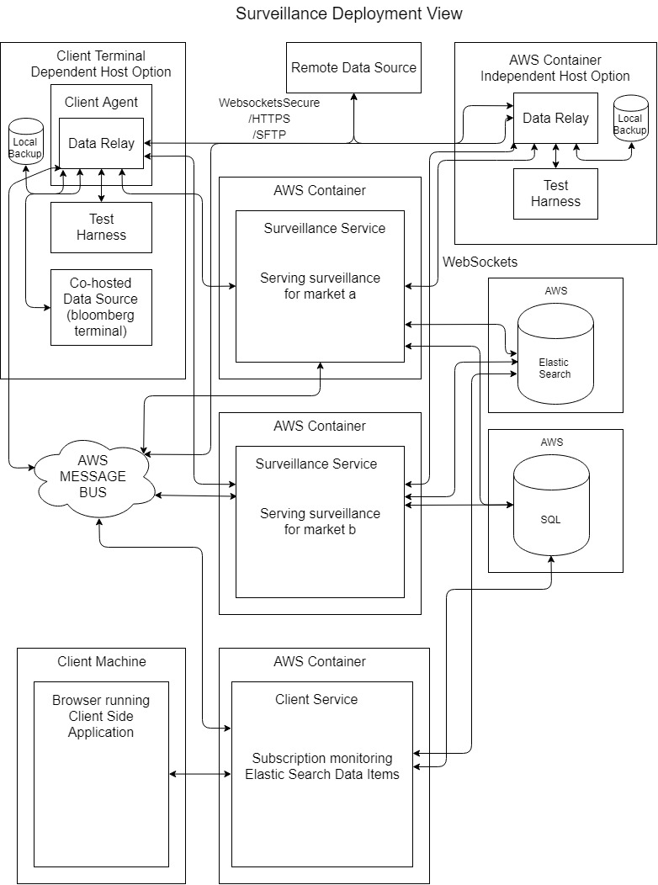

## Work Assignment View

Surveillance system is divided by module. Organisational units reflect the most extreme division of work possible; not the best division of work advised.

|  |  |  |
| --- | --- | --- |
| Module. Test Harness |  |  |
| Segment | **Subsystem** | **Organisational Unit** |
| UI/CLI | Console Screen I/O | Dev 1 |
|  | Console Arguments | Dev 1 |
| Rogue Trade Generation | Random trade order generator | Dev 2 |
|  | Trade to FIX format projector | Dev 2 |
| Rogue Security Trading Generation | Random security spread/volume walk generator | Dev 3 |
|  | Security to B-Pipe-like output format | Dev 3 |
| Network IO | Web socket connections to the data relay | Dev 4 |
|  | Message bus to start / stop | Dev 4 |
|  | Message bus to run a specific trading profile. | Dev 4 |
| Alert Reconciliation | Alert watcher | Dev 5 |
|  | Surveillance alert failure notification | Dev 5 |
| Logs | Log failures to AWS | Dev 6 |
|  | Attempt self-recovery | Dev 6 |
| Config / Data Generation | Predefined trade and security data profiles | Dev 7 |
| Monitoring | Health Check | Dev 8 |
|  | Performance | Dev 8 |

|  |  |  |
| --- | --- | --- |
| Module. Data Relay |  |  |
| Segment | **Subsystem** | **Organisational Unit** |
| Data IO | Connect to data source | Dev 1 |
|  | Connect to data recipient | Dev 1 |
|  | Local storage failover for network issues | Dev 2 |
| Licencing | Apply licencing concerns to data source data stream | Dev 1 |
| Network IO | Message bus to start/stop | Dev 3 |
|  | Update licencing file remotely | Dev 3 |
|  | Message bus to set data source | Dev 3 |
| Config | Data source connection details | Dev 3 |
|  | Data relay schedule (live/batch) | Dev 5 |
| Logs | Log failures to AWS | Dev 4 |
|  | Attempt self-recovery | Dev 4 |
| Monitoring | Health Check | Dev 6 |
|  | Performance | Dev 6 |

|  |  |  |
| --- | --- | --- |
| Module. Surveillance Service |  |  |
| Segment | **Subsystem** | **Organisational Unit** |
| Analysis | Price input to in memory stream | Dev 1 |
|  | Trade input to in memory stream | Dev 1 |
|  | Stream of streams data structure | Dev 3 |
|  | Rule to stream application engine | Dev 4 |
|  | Rules [1..n] | Devs [1..n] |
| Alerts | Alert generator | Dev 5 |
|  | Alert evidence gatherer | Dev 5 |
|  | Alert scorer | Dev 5 |
| Batch | Batch processing by file | Dev 6 |
|  | Batch processing by date range | Dev 6 |
| Network IO | Web sockets to Data Relay/s | Dev 7 |
|  | Elastic search data store | Dev 8 |
| Data Storage | Elastic search | Dev 9 |
|  | Sql Server | Dev 10 |
|  | Reddis Backplane | Dev 11 |
|  | Stream data to elastic search data storage | Dev 12 |
| Config | Define data relays | Dev 1 |
| Logs | Log failures to AWS | Dev 13 |
|  | Attempt self-recovery | Dev 14 |
| Monitoring | Health Check | Dev 15 |
|  | Performance | Dev 15 |

|  |  |  |
| --- | --- | --- |
| Module. Client Service |  |  |
| Segment | **Subsystem** | **Organisational Unit** |
| Alert Subscription | Monitor new alerts being generated in elastic search | Dev 1 |
| DTOs | Update dtos for evidence gatherer and scorer | Dev 2 |
| Services | Update services for exposing evidence/scores for alerts | Dev 3 |